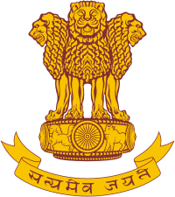

**Jawaharlal Institute of Postgraduate Medical Education and Research (JIPMER)**

**Puducherry – 605006**

(An Institute of National Importance Under Ministry of Health & Family Welfare, Govt. of India)

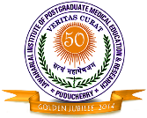****

**TELEMEDICINE SERVICES**

**National Medical College Network (NMCN)**

**Regional Resource Centre (RRC) JIPMER**

**“JIPMER Providing Health Services to Pilgrims of Aayyapa Temple Sabarimala through Telemedicine using Satellite (ISRO) Connectivity”**

JIPMER is fully equipped with all Telemedicine Equipment and infrastructure including Satellite (ISRO) and High Bandwidth Internet Connectivity. JIPMER is running various Telemedicine Projects like National Knowledge Network (NKN) Project, National Medical College Network (NMCN) Project, Indian Space Research Organization (ISRO) Project, OncoNet Project, Tele-Ophthalmology Project and Virtual Class Room Project. JIPMER has been utilizing Telemedicine for Patient Care, Tele-Education, Tele-OPD, Tele-Emergency, Tele-ICU Monitoring, Tele-Follow up Clinic, Tele-Consultations, Tele-Health Camps, etc. In 2013, Ministry of Health and Family Welfare (MOH&FW), Govt. of India designated JIPMER as Regional Resource Centre (RRC) for Telemedicine for Medical Colleges of South India (Andhra Pradesh, Karnataka, Kerala, Tamilnadu, Puducherry & Telangana). As per the instruction of MOH&FW, Govt. of India, In 2013, JIPMER has organized Telemedicine Network Workshop for Sensitization of Medical Colleges of South India for effective utilization of Telemedicine for Patient Care and Health Education. JIPMER has been innovative in developing indigenous cost effective Mobile Telemedicine Console (Kiosk) for various Telemedicine activities. JIPMER regularly Live Telecasting of Lectures, CMEs, Workshops, Conferences and Surgeries for which ‘Oscar of Medicine BMJ Award’ was awarded in 2014. One of the Application of Telemedicine is to provide Tele-Consultation to patients remotely where there is risk of Stampede and Injuries. Every year there is an incidence of Stampede and deaths during Pilgrimage to Lord Aayyapa in Sabarimala, Kerala. Hon’ble Prime Minister of India has taken initiatives through Ministry of Health and Family Welfare (MOH&FW) and Indian Space Research Organization (ISRO) to provide Medical care to Pilgrims of Aayyapa Temple using Telemedicine Services. A timely help by providing Tele-Consultation by Specialist to Health provider at Sabarimala can save lives of many Pilgrims. JIPMER has been identified by Govt. of India to provide Tele-Consultations by Specialists of JIPMER to primary health care provider at Sabarimala. Prof Dr S C Parija Director JIPMER conducted Tele Video Conferencing meeting with Union Health Secretary to appraise of JIPMER plan of helping the Pilgrims.

JIPMER has made a Duty Roaster (24x7) for Doctors on shift basis for 8 hours duty with physical availability of one post graduate Resident and one Senior Resident, with Faculty on call.

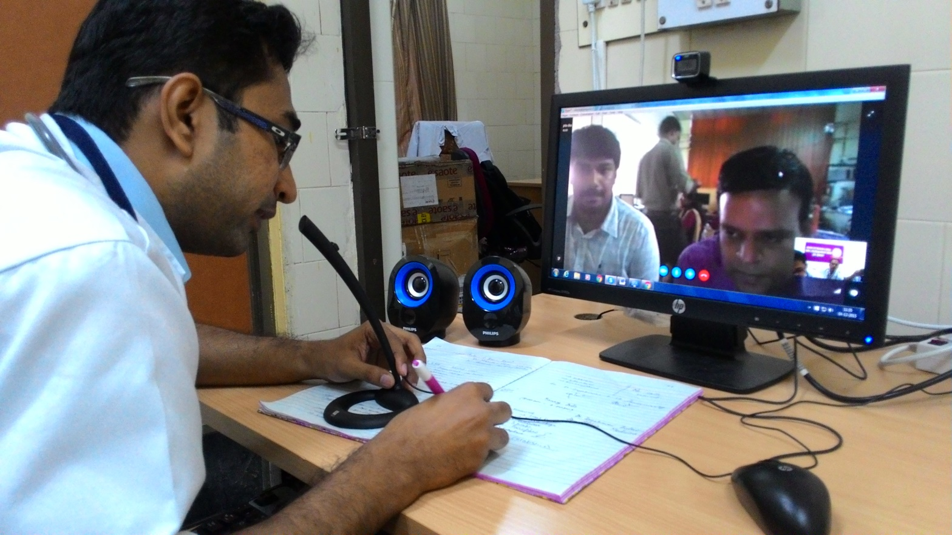

**Video Conferencing between JIPMER and Sabarimala Telemedicine Centre using ISRO Satellite Connectivity**

**‘JIPMER Participates in Online CME Organized by ISRO through Satellite Connectivity’**

JIPMER has regularly participates in Online CME organized by ISRO through Satellite Connectivity. The Programme was coordinated by Telemedicine Nodal Officer and Professor of Department of Plastic Surgery, Dr Ravi Kumar Chittoria. The Programme was attended from JIPMER by Medicine and other Specialty doctors.

